
Study Plan & Schedule Tracker

Written By
Md Samiul Alam Rifad
mdsamiul.rif210@go.kauko.lt
Lecturer
Mustafa Shahrabani
mustafa.shahrabani@go.kauko.lt

Abstract
Currently, university and college students experience many difficulties, including academic stress, multiple subjects, and insufficient time to coordinate study activities. The lack of an easy-to-follow and organized planning procedure may lead students to lose track of accomplished tasks and upcoming assignments. This thesis will present the analysis and design of a single user web-based system for organizing and tracking study plans and schedules. The proposed system will enable the student to login, develop multiple study plans, specify dates and times, view schedules either by day or by week, and remove accomplished tasks on schedule. The developed system will be built on basic web technologies and will prioritize ease of use over complexity. The proposed system will be described through this report along with its requirements, structure, functionality, and expected performance.

1. Introduction

1.1 Brief Description of the System
1.2 Relevance of the System
1.3 Problem Statement
1.4 Goal of the Project
1.5 Report Structure Overview

2. Analysis of the Work Task

2.1 Target User Description
2.2 System Subject and Object
2.3 User Needs and Pain Points
2.4 Main User Tasks
2.5 System Boundaries
2.6 Workflow Diagrams for Main Tasks

3. Software Requirements Specification

3.1 Purpose of the Requirements
3.2 Functional Requirements
3.3 Non-Functional Requirements
3.4 Subsystem Requirements

4. Technology Overview

4.1 Selected Platform
4.2 Programming Languages
4.3 User Interface Technology
4.4 Data Storage Method
4.5 Justification of Technology Choices

5. Software Design and Architecture

5.1 Chosen Architecture Type
5.2 Main System Modules
5.3 Module Interaction
5.4 Input, Output, and Error Handling
5.5 System Architecture Diagram

6. Testing and Experimental Results

6.1 Purpose of Testing
6.2 Types of Testing Used
6.3 Test Cases
6.4 Evaluation of Expected Results

7. Conclusion

7.1 Summary of Work

7.2 Strengths of the System

7.3 Limitations

7.4 Future Improvements

1. Introduction
1.1 Brief Description of the System
This project is about a single-user web-based planning and schedule tracking system designed mainly for university and college students. This system helps students to complete their academic tasks like as studying, lecture review, and homework. It also allows the user to add study plans, set dates and times, and view schedules in an easy way.
A study plan and schedule tracker addresses these challenges by providing a structured, customizable, and user-friendly system for organizing study tasks. Integrating reminders, analytics, and time management tools, the tracker helps students create effective study routines and achieve better academic results.
1.2 Relevance of the System
Nowadays, University and college students usually study various types of subjects at the same time. Every subject may include many lectures, books, and assignments. For all of this, students often feel confused about what they have already finished and what still needs to be done. This system is helpful because it helps students clearly see their study plans and manage time better. It can reduce stress and improve daily study organization.

1.3 Problem Statement
Many students do not have a simple and structured way to track their study activities. They often rely on memory, paper notes, or different applications, which can cause missed tasks and poor planning. There is a need for a simple system that shows completed tasks and upcoming work in one place.

1.4 Goal of the Project
The goal of this project is to design and document a single-user web-based system that helps university and college students track their study plans and schedules.

1.5 Report Structure Overview
This report is organized into seven sections. The introduction presents the system and its purpose. The analysis section describes the user and tasks. The requirements section defines what the system should do. The technology overview explains selected tools. The design section shows system structure. The testing section describes expected system behavior. The conclusion summarizes the work and future improvements.
2. Analysis of the Work Task
2.1 Target User Description
The target user of the system is a single university or college student. The system is intended for personal academic use only. There is no interaction with other users.

2.2 System Subject and Object
The subject of the system is study planning and time management. The object of the system is the set of study plans and tasks created by the student.

2.3 User Needs and Pain Points
Students often face with various subjects and large amounts of study material. They may forget which tasks are completed and which are still ongoing. The user needs a clear and simple way to manage study tasks and view schedules without unnecessary things.

2.4 Main User Tasks
The main tasks the user wants to perform are:
- Add a study plan or task
- Assign a date and time to a task
- View plans on a daily or weekly basis
- Delete completed or unnecessary tasks

2.5 System Boundaries
The system allows users to manage personal study plans only. It does not support notifications, task editing, or multiple users. The system works through a web browser and requires an internet connection.

2.6 Workflow Diagrams for Main Tasks
Below are simple workflow diagrams for each main task. These diagrams show the start point, user actions, system responses, and end point.

Diagram 1: Add a Study Plan or Task
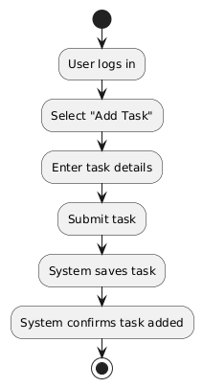
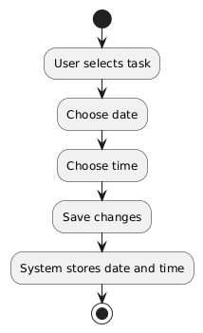

Diagram 2: Assign a Date and Time to a Task

Diagram 3: View Plans on a Daily or Weekly Basis
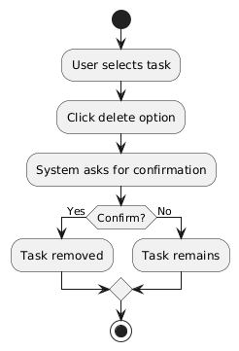
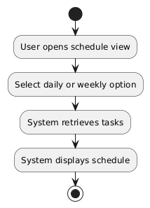

Diagram 4: Delete Completed or Unnecessary Tasks

3. Software Requirements Specification
3.1 Purpose of the Requirements
This section describes what the system is expected to do and how it should perform. The requirements are defined for a single-user academic system and focus on basic functionality only.

3.2 Functional Requirements
The functional requirements describe the actions the system must support.
- FR1: The system shall allow the user to log in using a username and password.
- FR2: The system shall allow the user to add a new study plan or task.
- FR3: The system shall allow the user to assign a date and time to a task.
- FR4: The system shall allow the user to view tasks in daily or weekly format.
- FR5: The system shall allow the user to delete completed or unnecessary tasks.
- FR6: The system shall store task data for later access.

3.3 Non-Functional Requirements
The non-functional requirements describe how the system should perform.
- Usability: The system should be easy to understand and simple to use for students.
- Performance: The system should respond to user actions without noticeable delay.
- Security: The system should restrict access using a login mechanism.
- Reliability: The system should not lose stored data during normal use.

3.4 Subsystem Requirements
3.4.1 Hardware Requirements
The system requires a device such as a laptop or desktop computer with internet access.
3.4.2 Software Requirements
A modern web browser that supports HTML, CSS, and JavaScript is required.
3.4.3 User Interface Requirements
The interface should use simple forms, buttons, and calendar views. Complex design elements are avoided.
3.4.4 Information Subsystem Requirements
The system stores study plans and schedule data locally in the browser using local storage.

4. Technology Overview
4.1 Selected Platform
The system is designed as a web application. This platform is chosen because it is easy to access and does not require installation.

4.2 Programming Languages
HTML is used to structure the content of the web pages. CSS is used for layout and visual styling. JavaScript is used to handle logic, user interaction, and data storage.

4.3 User Interface Technology
The user interface is built using standard web technologies. Forms are used for input, and simple layouts are used for displaying schedules.

4.4 Data Storage Method
The system uses browser local storage to save user data. This method is suitable for a single-user system and avoids the need for external databases.

4.5 Justification of Technology Choices
Technology | Justification
Web platform | Easy access and no installation required
HTML/CSS | Simple and widely used for web interfaces
JavaScript | Handles logic and interaction
Local storage | Suitable for single-user data storage

5. Software Design and Architecture
5.1 Chosen Architecture Type
The system follows a simple layered architecture. Each layer has a clear responsibility, which makes the system easier to understand.

5.2 Main System Modules
- Login Module: Handles user authentication.
- Plan Management Module: Manages adding and deleting tasks.
- Schedule Display Module: Shows tasks in daily or weekly views.

5.3 Module Interaction
The user interacts with the user interface. User actions are processed by the logic layer. Data is stored or retrieved from local storage.

5.4 Input, Output, and Error Handling
- Input: Task name, date, time, login credentials
- Output: Displayed schedules and confirmation messages
- Error Handling: Error messages are shown for invalid login or missing input

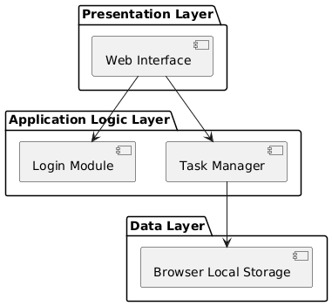

5.5 System Architecture Diagram (PlantUML)

6. Testing and Experimental Results
6.1 Purpose of Testing
Testing is described to show how system quality could be ensured. The testing is theoretical and based on expected behavior.

6.2 Types of Testing Used
- Functional testing
- Usability testing
- Security testing
6.3 Test Cases
Test Case ID | Description | Expected Result
TC1 | Login with valid credentials | Login Successful
TC2 | Login with invalid credentials | Error message shown
TC3 | Add a study task | Task saved and displayed
TC4 | View daily schedule | Correct tasks shown
TV5 | Delete a task | Task removed

6.4 Evaluation of Expected Results
Based on the expected results, the system design fulfills the basic requirements of a single-user study planning system. The system is considered usable and reliable for academic purposes.

7. Conclusion
7.1 Summary of Work
This project presented the analysis, design, and documentation of a single-user web-based plan and schedule tracking system for students. The system focuses on basic planning features.

7.2 Strengths of the System
The main strength of the system is its simplicity. It is easy to understand and suitable for individual academic use.

7.3 Limitations
The system does not include reminders, task editing, or multi-user support. Data storage is limited to one browser.

7.4 Future Improvements
In future versions, the system could include notifications, cloud storage, and mobile device support to improve usability.

